**Smart Solar Energy Solutions for VN-Engineering**

VN-Engineering, a solar energy solution supplier based in the city of Groningen wants to extend their services. As the world shifts towards sustainable energy sources, solar power stands out for its potential to harness the sun's abundant energy. However, maximizing the efficiency, use and maintenance of solar energy is a complex challenge that requires an understanding of various models and their practical applications. VN-Engineering is looking to extend their portfolio to smart solar energy solutions.

In this exercise your task is to explore three key models: statistical, structural causal, and physical. Each model offers unique insights into solar panel yield and efficiency. By understanding these models, you will propose new services for VN-Engineering, focusing on solar panel production, installation, or maintenance. Your ideas will help VN-Engineering extend their portfolio and optimize solar panel performance.

**Statistical Model**

Explore how the statistical model can compare the yield of different solar panels. Identify services VN-Engineering could offer based on comparative yield data. Consider how statistical analysis can help customers. Discuss potential limitations of statistical models.

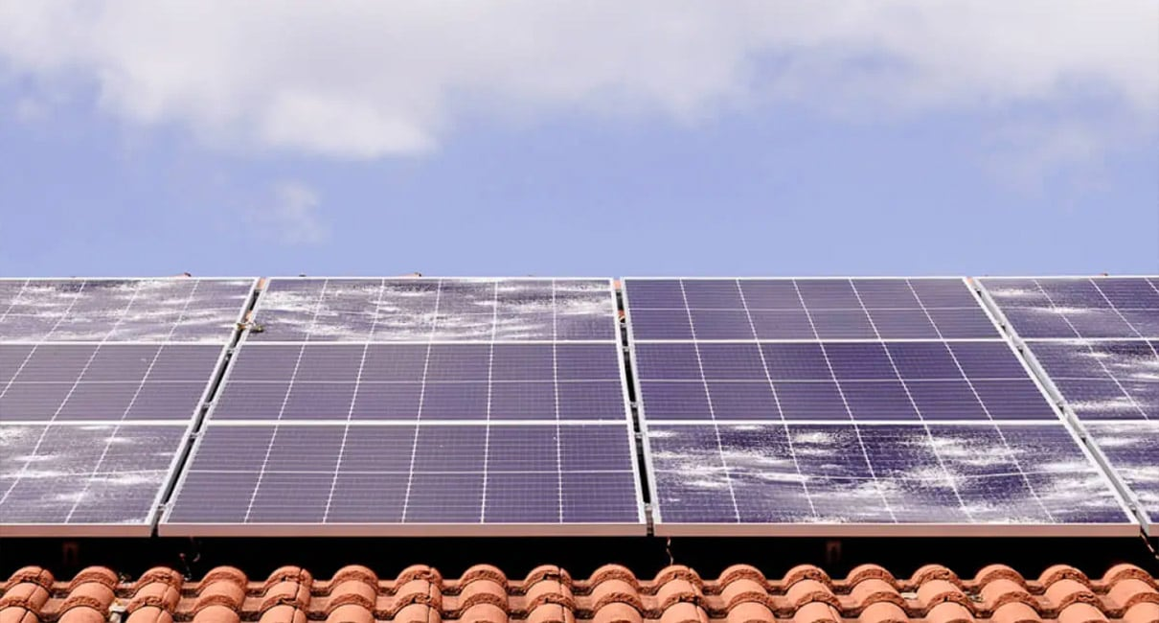

*Source: https://www.velosolar.com/can-hail-damage-solar-panels/*

**Structural Causal Model**

Investigate how the causal model can predict solar panel yield based on estimated future conditions. Propose services that utilize causal predictions to offer commercial benefits. Outline where causal models might not accurately predict outcomes.

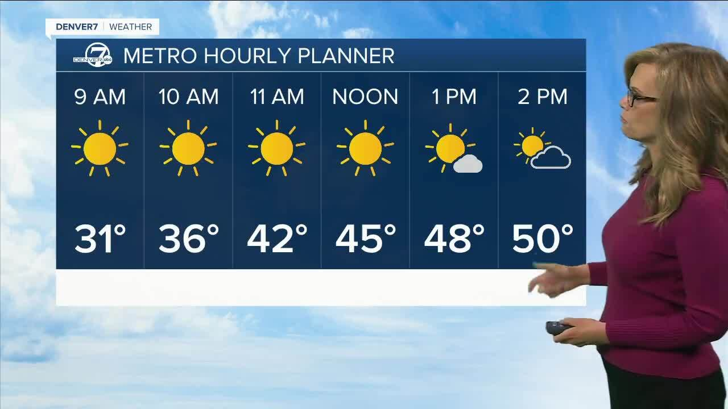

*Source: https://www.denver7.com/weather/forecast-parent/mild-and-dry-in-denver-through-thursday*

**Physical Model**

Understand how the physical model determines the optimal yield of solar panels. Suggest services focused on the installation and design of solar panel systems, using physical parameters (e.g., orientation, angle) to maximize efficiency. Highlight the limitations of physical models in real-world scenarios and suggest how to overcome them.

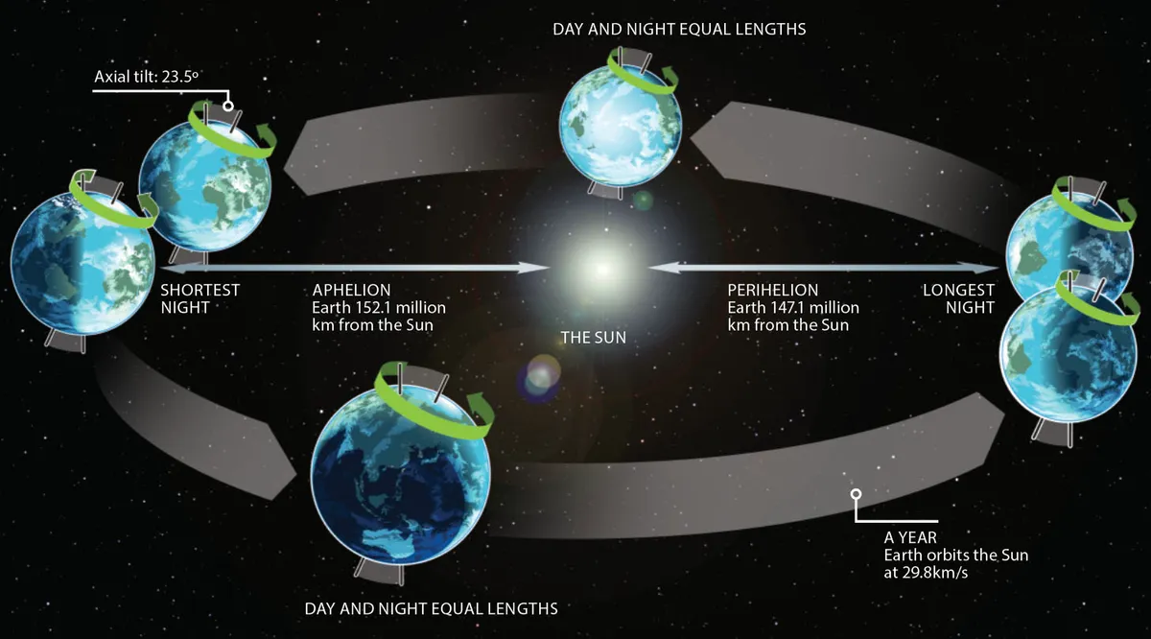

*Source: https://www.skyatnightmagazine.com/advice/how-does-earth-orbit-the-sun*